**Specification – Group B**

**Initial Designs:**

Within the application, there are 2 types of users: the students and the gamekeeper. The students will be the ones who are actively using the application, whilst the gamekeeper has more of an overseeing and monitoring role.

**User Homepage:**

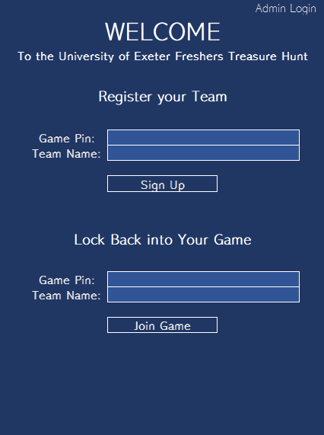

This is the initial designs for the front-page which the users will interact with. There will be two options, either creating a new game or joining a game. To successfully create a new game, the students would have to be given a pre-generated pin from the gamekeeper, as well as providing a unique team name.

If a student’s phone battery dies, they can resume the game on another phone, just by entering their team name and game pin.

There is also a button in the top-right for the admin/gamekeeper to login.

**Dashboard:**

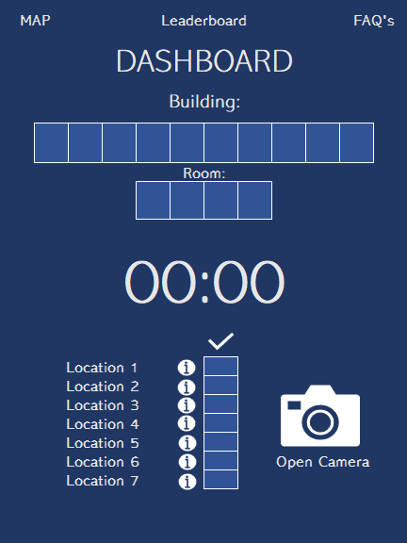

This is the design for the actual game. We have chosen to implement a hangman style game, where with each successful location visited and question answered, they unlock a letter of the building. At the end, once they have completed all of the locations and obtained all of the letters of the building, the location of their tutor’s room will be presented. Therefore, this omits team’s learning where they will meet there room by guessing the building location. For example, it is clear to see the word is “Harrison” by only obtaining “HA_RR_S_N” letters.

The locations are known to the student’s from the get-go. This ensures that all students are not necessarily going in the same order – alleviating the stresses of 140 students rushing to Location X. When the team gets to a location, they will scan a QR code to obtain the question in which they can answer. Upon successful answering, they will be presented with a letter for the building location.

The design shows a timer too. This will begin the moment the team scans the first QR code and will stop when the team answers the last question to complete the building location. This is a method of ranking, to see which team finished the quickest – adding a strong competitive and fun element.

To add usefulness to the application, there are options to view a map of the University, with more detailed maps for locations such as accommodation and lecture buildings. There is also a feature for FAQs, which will be very useful for fresher students.

**Game Keeper Dashboard:**

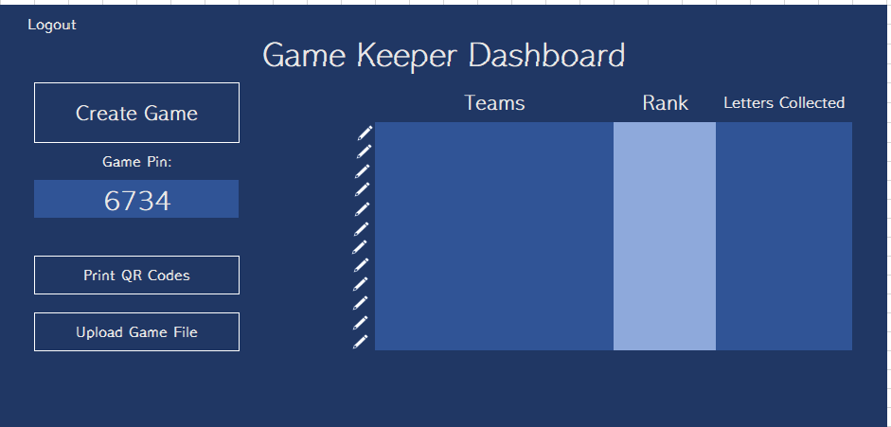

This is the dashboard for the gamekeeper. They are able to create games in the form of generating a game pin which they can give to their students to sign up with. They can also print off the QR codes and upload game files. The upload of game files means that this game can be extended outside of Computer Science, as the questions and building/room can be substituted to suit any discipline.

On the right will be a leaderboard. This will show the different teams that are currently playing, their rank and the number of letters they have collected.

**Further Designs:**

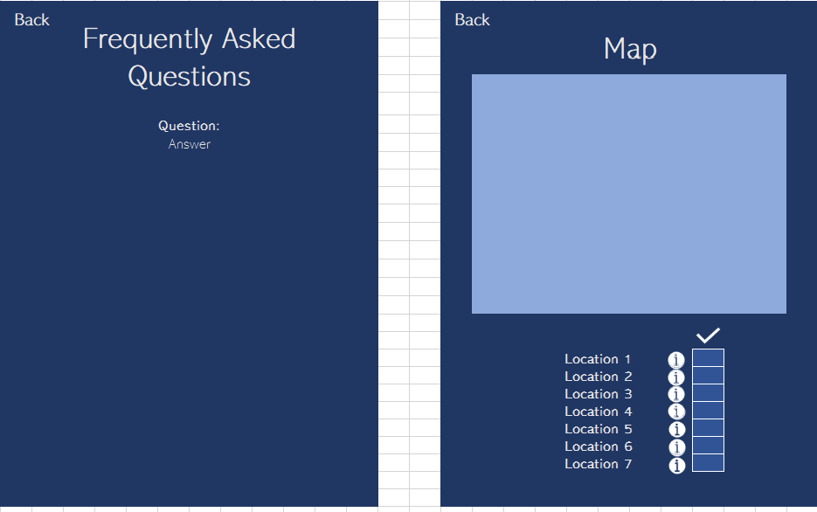

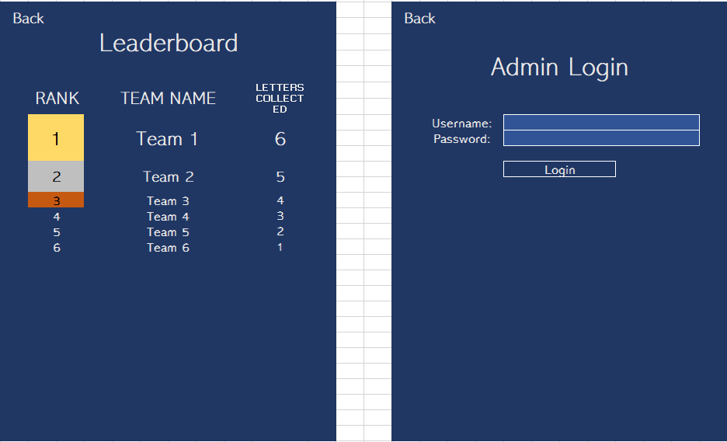

**Minimal Viable Product:**

The minimal viable product which we propose will include the above featured within the different design pages. It will provide the students to register for a new game, with the game pin provided by the gamekeeper. The teams will have to go to different locations, scan a QR code and answer the question successfully to obtain a letter, which will in turn, spell out the building of the tutor’s location. Only once they have obtained all of the letters will the room of their tutor be presented.

To add a sense of competitiveness into the game, there will be a timer to showcase how quickly teams have finished the hunt. The gamekeeper can choose to do with this information what they wish – at the least – it provides a sense of accomplishment between the teams. To ensure the application benefits the students wider than the hunt, there will be pages for FAQs and useful information about the University. This will include information about exams, housing, different lecturers and buildings.

**Specification Updated – 11/02/2020**

**Implementing Matt’s Requirements From Specification Sign-Off**

The above was signed-off (with few implementations needed) on the 5th February 2020.

To reflect upon Matt’s reply on our specification, we have added some changes. Firstly, our game’s registration has changed such that you also need to select your tutor. When you enter a valid game pin, there will be a select drop menu containing all of the tutor’s registered with that particular game, as long as the game is valid. Until the game pin entered is a valid game pin of an active game, the select drop menu will remain empty. Once a valid pin is entered, the teams will pick their tutor and start the game. Within the useful information part of the application, there will be a section on lecturers. From this page, the users can see information about not only their tutor, but also their lecturers. Information will include a picture of them, what they do, a link to their Exeter University online page, their email address and the location of their office. This information will be suffice for a student to gain more information about the particular person.

**Updated Designs: (UI Designs Sprint 1)**

**User Homepage:**

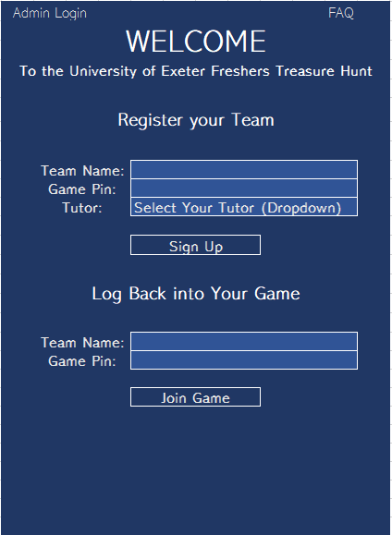Note: The FAQs page has been added to the homepage too.

The Tutor selection dropdown

**Useful Information:**

The useful information section can really be seen as: 1) useful information in terms of buildings, 2) useful information in terms of lecturers and 3) FAQs.

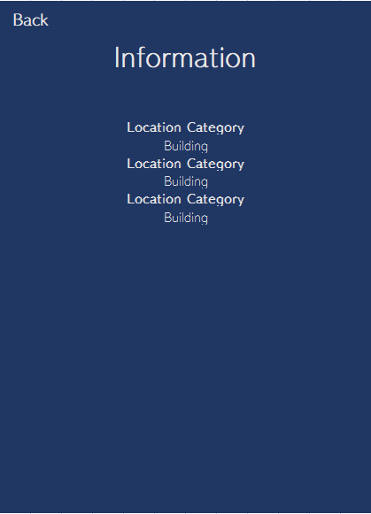

This is a design that would suit the typical structure of 1) and 2).

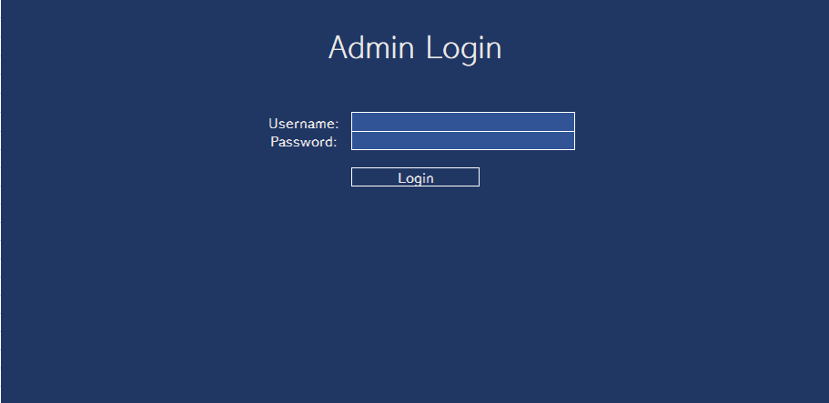 **Admin Login:**

We adjusted the Admin (gamekeeper) login page to a landscape orientation. This is because the gamekeeper is most likely going to access the admin page on their laptop/computer to create games or track games. We will make it as responsive as possible for mobile, but creating designs for its landscape (laptop/computer) use is more suitable.